Java 8 ( From this jdk

## Why?

1. Concise and minimal code
2. To utilise functional programming benefits in Java

But still it is OOp lang

1. Enable parllel programming (more compatible code for multi core processors)
2. More Readable and reusable and testable

## Parallel Programming Example in java

import java.util.Arrays;

public class ParallelStreamExample {

public static void main(String[] args) {

// Example data

int[] numbers = {1, 2, 3, 4, 5, 6, 7, 8, 9, 10};

// Sequential processing

Arrays.stream(numbers)

.forEach(System.out::print);

System.out.println();

// Parallel processing

Arrays.stream(numbers)

.parallel()

.forEach(System.out::print);

}

}

In the parallel processing example, the .parallel() method is invoked on the stream to enable parallelism. The stream API and parallel processing features provided by Java 8 simplify the development of parallel applications, making it easier for developers to take advantage of multi-core processors.

## What is Functional Programming?

It is a Programming Paradigm, Functional programming treats computation as the evaluation of mathematical functions. It avoids changing state or mutable data, and functions are treated as first-class citizens.

1. Computation as Functions:

Imagine you have a list of numbers, and you want to do something with each of them. In functional programming, you'd think about it like applying a function (a rule) to each number to get a new result. 🙂 program flows(computation) through the functions

1. Avoiding Change of State

Variables doesn’t need to change.  
// Avoiding changing state

const originalArray = [1, 2, 3];

const newArray = originalArray.map(num => num * 2);

// originalArray is still [1, 2, 3]

console.log(originalArray);

1. Functions are First-Class Citizens

In functional programming, functions are like VIPs. You can pass them around just like you do with numbers or strings.   
1. They can be arguments to other functions,   
2. returned from functions,   
3. or stored in variables.

In simple terms, functional programming is like cooking with recipes. You have ingredients (data), recipes (functions), and you follow the steps without messing with the **kitchen** too much (avoiding changing state). It helps keep things organized and understandable.

Difference B/w Functional Programming & Procedural Programming?

Imperative Programming: (e.g. c,c++, and java(to some extend)

Definition: Imperative programming is like giving a set of step-by-step instructions to the computer. You tell the computer exactly what to do and how to do it.

# Imperative Python code to find the sum of numbers in a list

numbers = [1, 2, 3, 4, 5]

sum = 0

for num in numbers:

sum += num

print("Sum:", sum)

Procedural programming is a subtype of imperative programming where the program is organized into procedures (also known as routines or functions) that are executed one after another. It is just organised.

## Features of Java 8

1. Lambda Expression
2. Stream API
3. Date and time API
4. Base 64 Encode Decode
5. Method reference and Constructor reference
   1. **method::this: This syntax is not valid in Java**. The method reference syntax requires a class or an object followed by ::, then the method name. There is no concept of method::this in Java.
   2. this::method
   3. ArrayList::new
   4. String::valueOf
6. Default methods in interfaces
7. Static methods in interfaces
8. Functional interfaces
9. Optional class
10. Java IO improvements(for each method)
11. Collection api improvements (parallel streams)

Base64 is a class which has a static method getEncoder, which returns an object of Encoder class. encodeToString is an

## Lambda Expression

* Not having any name
* Not having any return type
* Not having modifier

Steps

1. Remove modifier
2. Remove return type
3. Remove method name
4. Place arrow

Private void add(int a,int b){

System.out.println(a+b);

}

(int a,int b) ->{System.out.println(a+b);}

**//1. using type inference int a to a,**

**// 2. remove {} if only one statement**

(a,b) -> System.out.println(a+b);

Private int getStringLenth(String str){

Return str.length(0;  
}

(String str) -> {return str.length()}

(String str) -> return str.length();

**//3. No return key word**

(str) ->str.length();

// **4. Remove () if only one param**Str ->str.length();

**Benefits of Lambda expression**

1. To enable functional programming in java
2. To make code more readable, maintainable and concise code
3. To enable parallel processing
4. JAR file size reduction
5. Elimination of shadow variables

## Functional Interface

Interface having exactly single abstract method.

-But can have any number of default and static methods

-We can invoke lambda expression by using functional interface.

@FunctionalInterface annotation can be used for Code readability. (Not mandatory)

Advantages of this annotation

1. Restricts Interface to be a Functional Interface

‘

### Inheritance in Functional Interface

An Interface extending a Functional Interface is also a Functional Interface, If it has no Other abstract methods written in it, In case the same abstract method is written here also then it is ok.

### Default Methods in Interface

interface Dictator

{

default void kill()

{

System.out.print(“kill”);

}

}

class Follower implements Dictator

{ }

public class Myclass

{

Follower f =new Follower(); ->works

Dictator d=new Dictator(); -> not works

Dicataor d=new Follower(); -> works

f.kill()-> works

}

#### Interesting example (Solution for Diamond Problem)

interface DemoInterface1

{

public default void display()

{

System.out.println("the display() method of DemoInterface1 invoked");

}

}

interface DemoInterface2

{

public default void display()

{

System.out.println("the display() method of DemoInterface2 invoked");

}

}

public class DemoClass implements DemoInterface1, DemoInterface2

{

@Override **(Must Override Otherwise creates ambiguity & Error)**

public void display()

{

DemoInterface1.super.display();

DemoInterface2.super.display();

}

public static void main(String args[])

{

DemoClass obj = new DemoClass();

obj.display();

}

}

### Static Methods in interface

1. Keyword static
2. contains complete definition of function
3. cannot be overridden
4. Can be used only By class Name.

// Online Java Compiler

// Use this editor to write, compile and run your Java code online

interface Hi

{

static void help()

{

System.out.println("simi");

}

}

public class Main implements Hi{

public static void main(String[] args) {

Main obj =new Main();

// obj.help();

// Main.help();

Hi.help();

}

}

// Online Java Compiler

// Use this editor to write, compile and run your Java code online

interface Hi

{

static void help()

{

System.out.println("simi");

}

}

public class Main implements Hi{

static void help()

{

System.out.println("heme");

}

public static void main(String[] args) {

Main.help();

Hi.help();

}

}

public interface Main {

public static void main(String[] args) {

System.out.println("Hello, World!");

}

}

## Lambda Expressions Usecase

Employee Interface with getName method

Software engineer class implementing Employee & have implementation of getName

Employee employee=new SoftwareEngineer()

employee.getName();

Employee employee =()->”Software Engineer”; // implementation for getName in Employee

System.out.println(employee.getName());

1. Interface reference can be used to hold lambda expression  
   Interface is like a datatype for literal like lambda expression  
   int a =5;  
   Employee emp=()->”SE”;
2. Using lambda expression we don’t need to use any separate implementation class

## Create a Thread using Lambda Expression

e.g.1 Runnable r=()->System.out.println("Threads using lambdas");

Thread childThread=new Thread(r);

childThread.start(); // we can also use childThread.run();

e.g.2 Runnable r=()->{

for(int i=0;i<10;i++) {

System.out.println(“hello”+i);

}

};

Thread childThread=new Thread(r);

childThread.start(); // we can also use childThread.run();

## 

## Comparator using lambda Expressiong

1. Collections.sort(array,new Comparator<Integer>() {

@Override

public int compare(Integer o1, Integer o2) {

// TODO Auto-generated method stub

return o2-o1;

}

});

**Collections.sort(array,(a,b)->b-a);**

1. set<Integer> s=new TreeSet<>((a,b)->b-a); //using comparator for descending order
2. Map<Integer> m=new TreeMap<>((a,b)->b-a); // same as before
3. Custom objects sorting  
   Student s1=new Student(id:2,name:”vipul”);  
   Collections.sort(lis,(a,b) -> b.id-a.id);

## Anonymous Class Vs lambda Expressions

Round 1: when interface has multiple methods. Score: 1 - 0

interface Employee

{

public String getName();

public String getDesignation();

}

public class Tester

{

public static void main(String []args)

{

Employee e=new Employee() {

@Override

public String getName()

{

return "";

}

@Override

public String getDesignation()

{

return "";

}

};

**e.getName();**

}

}

Round 2: when we have Abstract class instead of interface. Score 2-0

Round 3: simple structure Score 2-1

when a variable is written Inside a lambda expression It becomes Final.

Plot twist: if the variable is declared or initialised within the lambda function then it is not final. That variable is not accessible to outside

E.g 1

interface Employee

{

public String getName();

}

public class Tester

{

public static void main(String []args)

{

Employee e=()->"";

int a=9;

Employee ee=()->{

a=6; // **Gives Error here.**

return ""+a;

};

System.out.println( ee.getName());

}

}

**E.g . 2**

**inte**rface Employee

{

public String getName();

}

public class Tester

{

public static void main(String []args)

{

Employee e=()->"";

int a=9;

Employee ee=()->{

return ""+a; // Gives error at a. Since we written a in lambda expression. we cannot do a=10 below.

};

a=10;

System.out.println( ee.getName());

}

}

**E.g. 3**

public class Tester

{

int a=11; **// class variable doesn’t effect lambda expression in class method.**

public static void main(String []args)

{

doSomething();

}

public static void doSomething()

{

Employee e=()->"";

Employee ee=()->{

int a=10; // **same variable name as instance variable.**

return "";

};

System.out.println( ee.getName());

}

}

**E.g. 4**

public class Tester

{

int a=11;

public static void main(String []args)

{

Tester obj=new Tester(); // Since I cannot use instance variable in static method doSomething created obj.

obj.doSomething();

}

public void doSomething()

{

Employee e=()->"";

Employee ee=()->{

a=66;

return "";

};

System.out.println( ee.getName());

}

}

Error cases:

* int a;

Employee ee=()->{

a=10; // Final variable must be initialised at int a;

return "";

};

* int a=6;

Employee ee=()->{

int a; // cannot Redeclare

return "";

};

## 

## Predicate

1. ArrayList<Integer>arr=new ArrayList<>(Arrays.asList(1,2,5,3,4));

int sum=arr.stream().filter(n->n%2==0).mapToInt(n->n).sum();

System.out.print(sum);

1. Predicate<Integer> p=a->a>0;

p.test(2);

1. Predicate<String>startsWithV=s->s.toLowerCase().charAt(0)==’v’;
2. Predicate<String>endsWithL=s-s.toLowerCase().charAt(s.length()-1)==’l’;

### And, OR, negate, isEqual(static method unlike others)

1. Predicate<String>startVendL=startsWithV.and(endsWithL);  
   startVendL.test(“Vipul”);
2. Similarly or
3. Predicate<String>notStartsWithV=startsWithV.negate();  
    startsWithV.negate().test(“vipul”);
4. Predicate<Object>p=Predicate.isEqual(“equalitychecking”);  
   p.test(“equalitychekcing”)

## Function

* Function<T,R> T is parameter type and R is return type.

Function<String,Integer>fun=n->n.length();

Function<String,String>fun2=n->n.substring(0,3);

Function<List<Student>,List<Student>>studentsWithVipAsPrefix=n->n.filter(n.getName().toLowerCase().matches(“Vip%”))

### Know the normal Usage with this code.

class Student

{

private String name;

public String getName()

{

return "abc";

}

}

public class Tester

{

public static void main(String []args)

{

Function<String,Integer>len=String::length;

Function<String,String> fun=n->n.substring(0,3);

Function<List<Student>,List<Student>>vips=studentList->{

List<Student> result=new ArrayList<>();

for(Student student:studentList)

{

if(fun.apply(student.getName()).equalsIgnoreCase("VIP"))

{

result.add(student);

}

}

return result;

};

List<Student>studentList=new ArrayList<>();

List<Student>studentvipslist=vips.apply(studentList);

}

}

### Andthen

Function<String,String>len=String::toUpperCase;

Function<String,String> fun=n->n.substring(0,3);

Function<String,String> hybrid=len.andThen(fun);

hybrid.apply("Random");

fun.andThen(len).apply("another Random");

Function<Integer,Integer>twice=n->2*n;

Function<Integer,Integer>cube=n->n*n*n;

twice.andThen(cube).apply(10);

cube.andThen(twice).apply(10);

cube.compose(twice).apply(10); // This is not a new one same as above line

Identity it is a static method in Fucntion interface

Function<String,String>identityFunction=Function.identity();

identityFunction.apply(“Vipul”) -> Gives Vipul // same output as input

Consumer:

Consumer<String> consumer=s->System.out::println

Consumer.accept(“Vipul”);

Consumer<List<Integer>>listConsumer=li->{

for(Integer i: li)

{

System.out.print(i+100);

} };

Consumer<List<Integer>>listConsumer2=li->{

for(Integer i: li)

{

System.out.print(i);

} };

listConsumer.accept(Arrays.asList(1,2,3,4));

And Then

listConsumer2.andThen(listConsumer1).accept(Arrays.asList(1,2,3));

Supplier:

Supplier<Integer>supplier1=()->”vipulSharma”;

Supplier1.get();

All in one:

Predicate<Integer>p=x->x>0;

    Supplier<Integer>s=()->23;

    Function<Integer,Integer>f=n->n*10;

    Consumer<Integer>c=System.out::println;

    if( p.test(s.get()))

    {

     c.accept(f.apply(s.get()));

    }

BiPredicate, BiFunction, BiConsumer & No BiSupplier(X):

BiPredicate<Integer,String>bipredicate=(n,s)->(n>0)&&(s.isEmpty());

c.accept(bipredicate.test(22, "d"));

BiFunction<Integer,String,String>bifunction=(n,s)->s+n;

bifunction.apply(23, "Student RegisterId is: ");

BiConsumer<Integer,String>biconsumer=(n,s)->System.out.println(n+s);

// No BiSupplier. Because we cannot return two values :) No Producer & No BiProducer :)

UnaryOperator & BinaryOperator:

Function<Integer,Integer>fun=a->a*10;

// Instead of writing <Integer,Integer> can we write <Integer>?

UnaryOperator<Integer>funUO=a->a*10;

BiFunction<Integer,Integer,Integer>sum=(a,b)->a+b;

BinaryOperator<Integer>sumUO=(a,b)->a+b;

MethodReference & ConstructorReference

MethodReference allow us to refer a method without invoking it(we won’t invoke the method like fun()),Making our code cleane & more readable. They can be used in place of a lambda expression when the lambda expression only calls an existing method

1. It referes method

2. In place of lambda expression

public class Tester {

public static String play(String game)

{

return "Playing"+game;

}

public static void main(String args[])

{

    UnaryOperator<String>status=Tester::play;

    status.apply("cricket");

}

}

ConstructorReference:

*Streams are used to enable lambda operations

List<String>names=Arrays.asList(“alice”,”Bob”);

List<String>students=names.stream().map(Student::new).collect(Collectors.toList());

## Stream

* Stream.range(1,5) // Not applicable ** Throws Error.
* Stream.iterate(1,n->n+1) // Applicable

A stream is a collection that is used on Collections enabling the use of declarative and functional methods such as map, filter, reduce

//imperative approach

   int sum=0;

   int []arr= {2,3,4,5,6};

   for(int i=0;i<arr.length;i++)

   {

    if(arr[i]%2==0)

    {

    sum+=arr[i];

    }

   }

    //Declarative approach

   sum=Arrays.stream(arr).filter(n->n%2==0).sum();

   sum=Arrays.stream(arr).filter(n->n%2==0).reduce((a,b)->a+b).orElse(0);

   System.out.print(sum);

    Uses:

Readability

Flexibility -> more operations we can do

Parallelism ->Divided into chunks & processed in parallel

Encapsulation

Conversions / Creations:

Stream<String>myStream=list.stream();

Stream<String>stream=Arrays.stream(array);

Stream<Integer> integerStream=Stream.of(1,2,3);

Stream<Integer>limit=Stream.iterate(0,n->n+1).limit(100);

Stream<String> limit1=Stream.generate(()-> “hello”).limit(5);

Stream<String> limit2=stream.generate(()->(int)Math.random()*100).limit(5);

#### Stream Operations

1. Filter → returns filtered elements

2. Map

1. .mapToInt, .mapToLong, .mapToDouble: These are specialized mapping functions used when you want to convert the elements of a stream to primitive data types (int, long, or double). The advantage of these methods is that they avoid the overhead of boxing and unboxing when working with primitive types, potentially improving performance.
2. .mapToObj method in Java streams is used to convert primitive values (such as int, long, double) into their corresponding wrapper objects (like Integer, Long, Double).  
   e.g:  
   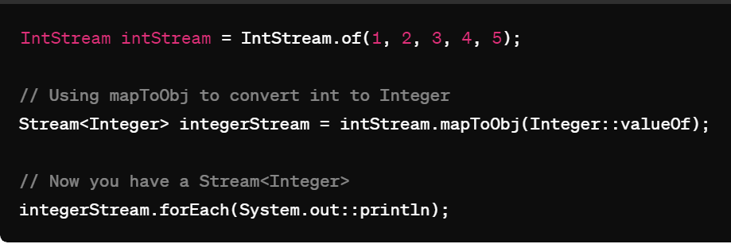

3. Collect(Collectors.toList());

4. Distinct

5. Sorted, sorted((a,b)->b-a).

6. Min(), Max() // returns optional

7. Peek

8. Limit, skip  
  
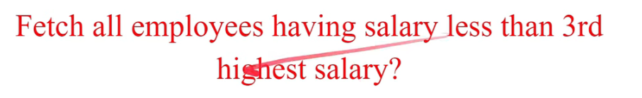

→ Sort desc & skip(3)

9. Reduce

10. .get()// returns answer for an optional output e.g. Min().get() like opt.get()

11. Count() // no of elements remaining

12. parallelStream(); // for very large streams only efficient // list.parallelStream()

List.stream().filter(x->x%2==0)

.map(x->x/2)

.distinct().sorted()

.limit(4)

.skip(1) // like offset in limit offset.

.peek(System.out::print) // a consumer prints each element

.collect(Collectors.toList());

Another example

Stream.iterate(0,x->x+1)

.limit(101)

.skip(1)

.filter(..)

.map(..)

.distinct()

.sorted()

.peek(system.out::print)

.collect(Collectors.toList());

***The findAny() method returns any element from a Stream, while the findFirst() method returns the first element in a Stream.

e.g 



#### IntStream in Streams

Sure! In Java, the `Stream` interface is part of the Java Stream API introduced in Java 8. It represents a sequence of elements that supports various operations to perform computations on those elements. The elements of a stream are processed in a pipeline, where intermediate operations produce new streams, and terminal operations produce a result or a side-effect. Streams allow for concise and functional-style code to work with collections and other data sources.

### Conversions using .toArray()

result.toArray(new int[result.size()][]);

only rows size is mandatory not the columns size? just like when passing 2d array to a function in c++?

Yes, you are correct. In Java, when converting a List<List<T>> to a 2D array T[][], only the number of rows (the outer array size) is mandatory. This is similar to passing a 2D array to a function in C++.

The expression `result.toArray(new int[result.size()][])` is used to convert a `List<int[]>` to a 2D array of `int` in Java. Let's break it down:

- `result`: This is a `List<int[]>` containing arrays of integers.

- `.toArray(...)`: This method is used to convert the list to an array.

- `new int[result.size()][]`: This part creates a new 2D array with the same number of rows as the size of the list `result`.

- `(int[result.size()][])`: This is a cast to the 2D array type.

So, this expression creates a new 2D array where each row corresponds to an array of integers from the `List<int[]>`.

### Questions:

1. **Conversion from List of Lists to 2D Array**:

- Convert `List<List<Integer>>` to a 2D array of `int`.

2. **Conversion from List of Strings to Array**:

- Convert `List<String>` to an array of `String`.

3. **Conversion from List of Doubles to Primitive Array**:

- Convert `List<Double>` to an array of `double`.

4. **Conversion from List of Characters to Array**:

- Convert `List<Character>` to an array of `char`.

5. **Conversion from List of Booleans to Primitive Array**:

- Convert `List<Boolean>` to an array of `boolean`.

##### My Answers with gpt Explinations

* List of Lists to 2D Array of int:
  + lis.toArray(new int[lis.size()][lis.get(0).size()]);
    - Here, new int[lis.size()][lis.get(0).size()] creates a 2D array with the same number of rows as lis, and the number of columns is determined by the size of the first sublist in lis. This is similar to C++ when passing a 2D array to a function where you provide the number of rows and columns.
* List to Array of String:
  + lis.toArray(new String[lis.size()]);
    - This converts a List<String> to an array of String, where the size of the array is the same as the size of the list. In this case, you only need to specify the number of elements (rows) in the resulting array.
* List to Array of Double:
  + lis.toArray(new Double[lis.size()]);
    - Similar to the previous example, this converts a List<Double> to an array of Double with the same size as the list.
* List to Array of char:
  + lis.toArray(new char[lis.size()]);
    - This would not work correctly because Java does not have a primitive type char[] as an array of objects. If lis is a List<Character>, you would need to convert each Character to char manually or use a stream.
* List to Array of boolean:
  + lis.toArray(new boolean[lis.size()]);
    - Similar to the char example, this would not work directly. If lis is a List<Boolean>, you would need to convert each Boolean to boolean manually or use a stream.

##### GPT’s Answers

### One-liner Implementations:

1. **List of Lists to 2D Array**:

```java

List<List<Integer>> list = new ArrayList<>();

int[][] array = list.stream().mapToInt(l -> l.stream().mapToInt(Integer::intValue).toArray()).toArray(int[][]::new);

```

**lis.toArray(new String[lis.size()]); is it required to give lis.size()?**

**ChatGPT**

**No, it is not required to specify the size when converting a List<String> to an array of String. You can simply use:**

**java**

**Copy code**

**String[] array = lis.toArray(new String[0]);**

2. **List of Strings to Array**:

```java

List<String> list = new ArrayList<>();

String[] array = list.toArray(new String[0]);

```

3. **List of Doubles to Primitive Array**:

```java

List<Double> list = new ArrayList<>();

double[] array = list.stream().mapToDouble(Double::doubleValue).toArray();

```

4. **List of Characters to Array**:

```java

List<Character> list = new ArrayList<>();

char[] array = list.stream().mapToInt(c -> (int) c).toArray();

```

5. **List of Booleans to Primitive Array**:

```java

List<Boolean> list = new ArrayList<>();

boolean[] array = list.stream().mapToBoolean(Boolean::booleanValue).toArray();

```

These one-liner implementations showcase how to convert different types of lists to arrays in Java using streams and lambda expressions.

## 

## Imp points in Streams (Ipis)

**IntStream has several methods that are specific to primitive int values, and these cannot be used directly on Streams of Objects. Here are some examples:**

1. **sum \*\*\*** No sum in Collections so ObjectStreams must be converted to InstStream to use this sum.
2. **average**
3. **min**
4. **max**
5. **summaryStatistics**
6. **.toArray**
7. **allMatch, anyMatch, NoneMatch**
8. **findFirst, findAny**

* **\*\*\* If you have a Stream<Integer> instead of an IntStream, you would first need to convert it to an IntStream using mapToInt before using these methods \*\*\***
* **sum() returns a primitive int value directly.**
* **reduce() returns an OptionalInt because it can handle cases where the stream is empty.**
* **reduce can be used for wrapper streams.**
* **Conventional way to map Integer to int → mapToInt(Integer::intValue)**
* **Use findFirst() after limit**

1. sorted() can be applied to both wrapper streams and primitive streams
2. Collectors.toList(), Collectors.toSet(), Collectors.joining() cannot be directly applicable to primitive streams
3. User
4. **Question:** I saw sorted((a,b)->b-a) not working for primitive streams
   1. Solution → convert to Wrapper(mapToObj) & convert Back to primitive(mapToInt).
   2. .boxed() converts the IntStream to a Stream<Integer> so we can use the sorted()
5. printing Tricks for Optional.
   1. lis.stream().reduce((a, b) -> a + b).ifPresentOrElse(
   2. **result -> {**
   3. **System.out.println("Result of reduction: " + result);**
   4. **System.out.println("Printing each element of list:");**
   5. **lis.forEach(System.out::print);**
   6. **},**
   7. () -> {
   8. System.out.println("List is empty.");
   9. }
   10. );

### Stream Interface

The `Stream` interface is a generic interface defined in the `java.util.stream` package with the following signature:

```java

public interface Stream<T>

```

- `T` represents the type of elements in the stream.

### IntStream Interface

`IntStream` is a specialized stream for handling primitive `int` values. It is an interface that extends `BaseStream`, providing additional methods for handling integer elements efficiently.

Here are some common methods provided by `IntStream`:

- **`map(IntUnaryOperator mapper)`:** Returns a stream consisting of the results of applying the given function to the elements of this stream.

- **`filter(IntPredicate predicate)`:** Returns a stream consisting of the elements of this stream that match the given predicate.

- **`sum()`:** Returns the sum of elements in this stream.

- **`average()`:** Returns the average of elements in this stream as an `OptionalDouble`.

- **`max()`:** Returns the maximum element in this stream as an `OptionalInt`.

- **`min()`:** Returns the minimum element in this stream as an `OptionalInt`.

- **`forEach(IntConsumer action)`:** Performs an action for each element of this stream.

- **`toArray()`:** Converts this stream to an array.

- **`anyMatch(IntPredicate predicate)`:** Returns whether any elements of this stream match the provided predicate.

- **`noneMatch(IntPredicate predicate)`:** Returns whether no elements of this stream match the provided predicate.

- **`allMatch(IntPredicate predicate)`:** Returns whether all elements of this stream match the provided predicate.

- **`distinct()`:** Returns a stream consisting of the distinct elements of this stream.

### Examples:

#### Using `IntStream`:

```java

IntStream.range(1, 6) // 1, 2, 3, 4, 5

.map(n -> n * n) // Square each element

.forEach(System.out::println);

```

Output:

```

1

4

9

16

25

```

#### Using `IntStream` to find sum:

```java

int sum = IntStream.of(1, 2, 3, 4, 5)

.sum(); // 15

```

#### Using `IntStream` with `anyMatch`:

```java

boolean hasEven = IntStream.of(1, 3, 5, 7, 8)

.anyMatch(n -> n % 2 == 0); // true

```

In summary, `IntStream` is a specialized stream for primitive `int` values, providing a set of methods optimized for handling integer elements efficiently. It's useful for operations that involve integer data, such as mathematical calculations, filtering, mapping, and more.

#### When to use Streams

##### Collections

Yes, streams can be used with most collections in Java. The Stream API was introduced in Java 8 and works with any class that implements the `Collection` interface or that can be converted to a collection.

Here are some common collections that you can use with streams:

1. **List**: Streams can be used with `ArrayList`, `LinkedList`, `Vector`, etc.

```java

List<Integer> list = new ArrayList<>();

Stream<Integer> stream = list.stream();

```

2. **Set**: Streams can be used with `HashSet`, `TreeSet`, `LinkedHashSet`, etc.

```java

Set<String> set = new HashSet<>();

Stream<String> stream = set.stream();

```

3. **Queue**: Streams can be used with `LinkedList` (as a `Queue`), `PriorityQueue`, etc.

```java

Queue<Integer> queue = new LinkedList<>();

Stream<Integer> stream = queue.stream();

```

4. **Map**: Streams can be used with `HashMap`, `TreeMap`, `LinkedHashMap`, etc.

```java

Map<String, Integer> map = new HashMap<>();

Stream<Map.Entry<String, Integer>> entryStream = map.entrySet().stream();

**Stream<String> keyStream = map.keySet().stream();**

**Stream<Integer> valueStream = map.values().stream();**

```

5. **Arrays**: Streams can be used with arrays.

```java

String[] array = {"apple", "banana", "cherry"};

Stream<String> stream = Arrays.stream(array);

```

6. **Streams from other sources**: Streams can also be created from other sources like files, ranges, etc.

```java

Stream<String> fileLines = Files.lines(Paths.get("file.txt"));

IntStream rangeStream = IntStream.range(1, 10);

```

In general, if a class implements the `Collection` interface (or `Map` for map-like collections), you can obtain a stream from it using the `stream()` method. Additionally, arrays can also be converted to streams using `Arrays.stream(array)`.

##### Other than Collections

Streams can be used on various data sources and operations beyond just collections. Here are some examples:

1. **Arrays**: Streams can be created from arrays using `Arrays.stream(array)`.

```java

int[] array = {1, 2, 3, 4, 5};

IntStream stream = Arrays.stream(array);

```

2. **Files**: Streams can be created from reading lines in a file.

```java

Path path = Paths.get("file.txt");

try (Stream<String> lines = Files.lines(path)) {

lines.forEach(System.out::println);

} catch (IOException e) {

e.printStackTrace();

}

```

3. **Range**: Streams can be created from ranges of numbers using `IntStream.range()` or **`LongStream.range()`.**

```java

IntStream numbers = IntStream.range(1, 10);

```

4. **Builder**: Streams can be built manually using `Stream.Builder`.

```java

Stream.Builder<String> builder = Stream.builder();

builder.add("one").add("two").add("three");

Stream<String> stream = builder.build();

```

5. **Regular Expressions**: Streams can be used to match elements based on regular expressions.

```java

Pattern pattern = Pattern.compile("\\d+");

Stream<String> numbers = Stream.of("1", "2", "three", "4");

Stream<String> matched = numbers.filter(pattern.asPredicate());

```

6. **APIs with Stream support**: Many Java APIs provide methods that return streams.

```java

// Stream of random integers

IntStream random = new Random().ints(5, 1, 100);

// Stream of lines from a BufferedReader

BufferedReader reader = new BufferedReader(new FileReader("file.txt"));

Stream<String> lines = reader.lines();

// Stream of process IDs

Stream<ProcessHandle> processIds = ProcessHandle.allProcesses();

```

7. **Parallel Streams**: Streams can be processed in parallel for improved performance.

```java

List<String> words = Arrays.asList("apple", "banana", "cherry", "date");

words**.parallelStream()**.forEach(System.out::println);

```

These are just a few examples. Essentially, streams can be used on any data source or collection that provides an appropriate method to create a stream.

## New Date & Time API:

Issues with legacy Date & Calendar classes

1. Mutable

2. Confusing (not thread safe)

3. Limited functionalities(zone ,diff)

New Classes

1. Local Date

2. Local Time

3. Local Date Time

4. Zoned Date Time

5. Instant

6. Period

7. Duration

8. Date Time Formatter

Local Date::

 Previous Package for LocalDate – Java.util package

New LocalDate is from Java-time

LocalDate now=LocalDate.now();

System.out.println(now); // 2023-04-23

Creating CustomDate object

LocalDate myDate=LocalDate.of(1990,2,27)

Now.getDayOfMonth(); 23

Now.getMonth(); APRIL to get value use Now.getMonthValue();

Now.getYear(); 2023

LocalDate today=LocalDate.now();

LocalDate yesterday=today.minusDays(1);

LocalDate pastDate=today.minusMonths(100);

If(today.isAfter(yesterday)) sysout(“yes”);

LocalTime::

LocalTime now =LocalTime.now(); // 15:37:33.613(nano seconds)

Now.get..()

Creating CustomTime object

LocalTime customTime=LocalTime.of(hour:14,min:30,sec:30);//sec is not required

String timeInString=”15:30:45”;

LocalTime timebyParse=LocalTime.parse(timeInString); //can replace the string with value

LocalTime BeforeOneHour=now.minusHours(1);

If(now.isAfter(BeforeOneHour)) System.out.print(“han bhai”);

 LocalDateTime::

LocalDateTime now=LocalDateTime.now(); // 2023-04-23T15:47:35.668 (T is seperator);

LocalDateTime.of(…)

LocalDateTime myDate=LocalDateTime.parse(“2023-01-11T13:48”); // don’t use 2023/01/11

Get,minus, isAfter etc…

ZonedDateTime:

UTC – Standard time for world

• LocalDateTime is UTC

ZonedDateTime now = ZonedDateTime.now();

Set<String> availableZoneIds=ZoneId.getAvailableZoneIds();

availableZoneIds.forEach(System.out::println);

Customzonedatetime

ZonedDateTime custom=ZonedDateTime.of(year,month,dayofMonth,hour,minute,second,nanosecond,ZoneId.of(“America”));

ZoneDateTime newYorkTime=ZoneDateTime.now(ZoneId.of(“America”));

ZoneId.of, Parse and get isbefore isafter also.

Instant

Long currentTimeMillis=System.currentTimeMillis();

Paste this value in epochconverter.com // Gives the value in milliseconds

Instant now=Instant.now(); // Gives the value in nanosecs 2023-04-24T03:18:17.448Z(Z is UTC)

Now.get..

Convert now to Zone-> now.atZone(ZoneId.of(“america”));

Duration

Instant start=Instant.now();

Instant end=Instant.now();

Duration d1=Duration.between(start,end); // PT0s (period time) (because both are nows)

Duration.of(amount,ChronoUnit.MILLIS);//PT0.001S

Instant start=Instant.now();

//logic of the code

Instand end=Instant.now();

System.out.print(Duration.between(start,end)); // Gives the time taken for logic

D1. -:compareTo, conversionstodate,etc..

Period:: (for large durations)

LocalDate now=LocalDate.now();

LocalDate then=LocalDate.of(1990,2,2);

Period period=period.between(now,then);

System.out.print(period);

Period. Plus, plusdays,plusyears, plusMontsh,getMonths..

DateTimeFormatter::

LocalDate localdate=LocalDate.parse(“2023-04-24”);

// I cannot give my format like 2023/04/24 Using DateTimeFormatter

DateTimeFormatter dateTimeFormatter=DateTimeFormatter.ofPattern(“dd/MM/yyyy”); // mm should be capital-> MM, because m is minute)

String date=”25/04/1998”; // myformatdate.

1.String format=localDate.format(myFormatter); // Gets present date in this format

2.LocalDate localdateInmyformat=LocalDate.parse(date,dateTimeFormatter);

String dateTimeString=”2023-04-24 10:30:45+5:30”;

DateTimeFormatter dateTimeFormatter=DateTimeFormatter.ofPattern(“yyyy-MM-dd HH:mm:ssXXX z”);

// XXX is for offset (+5:30) if we use IST instead of +5:30 it is not required.

ZonedDateTime zonedDateTime=ZonedDateTime.parse(dateTimeString,formatter);

System.out.println(zonedDateTime);

## Optional Class

It is like a box to values. In that box, it may contain value or contain null.

public class Test

{

public static void main(String[] args)

{

String name=getName(2);

if(name!=null){

System.out.println(name.toUpperCase());

}

}

// ASSUME AS DB

private static String getName(int id)

{

// db’s processing for id=1

return “Ram”

// db’s processing for id=3

return null;

}

}

public class Test

{

public static void main(String[] args)

{

Optional<String> name=getName(2);

if(name.**isPresent()**){

System.out.println(name.get());

}

// **using lambda expression for abovee**

name.ifPresent(x->System.out.print(x));

// **using method reference**

name.**ifPresent**(System.out::print());  
 **//other ways**

String name=name.isPresent()? name.get():”NA”;

name=name.orElse(“NA”);

name=name.orElseGet(()->”NA”)

name=name.orElseThrow(()->new NoSuchElementException());

// using method reference we -> NoSuchElementException::new

}

// ASSUME AS DB

private static String getName(int id)

{

//Db’s work

return Optional.empty() // Returns Empty or null values.

return Optional.of(name); // Doesn’t handle null values.Gets **NPException**

**// Use above only if you are 100% sure that name is not null.**

return Optional.ofNullable(name); //Solution for above. Returns Optional.empty();

}

}

Playing with the boxes

Optional<String>opt=getName(2);

Optional<String> opt1=opt.map(x->x.toUpperCase());

Opt1.ifPresent(System.out::println);

Optional<String>opt=getName(2);

Optional<Integer> opt1=opt.map(x->x.length());

Opt1.ifPresent(System.out::println);

#### .get()

**imp:** throws no such element Exception.

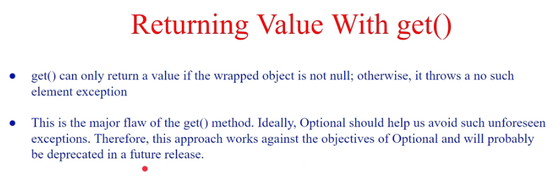

#### .ifPresent() & ifPresentOrElse()

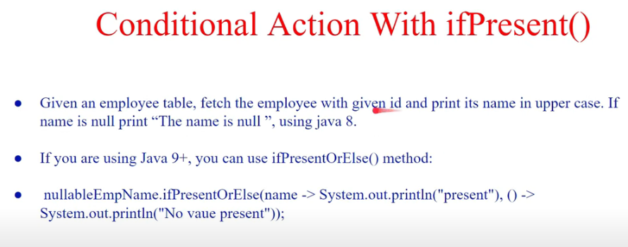

## orElse() & orElseGet()

**Imp:**

1. orElse takes single value, orElseGet() will take Supplier Functional Interface(lamda exp).
2. orElseGet() is performance efficient.

**orElse()**

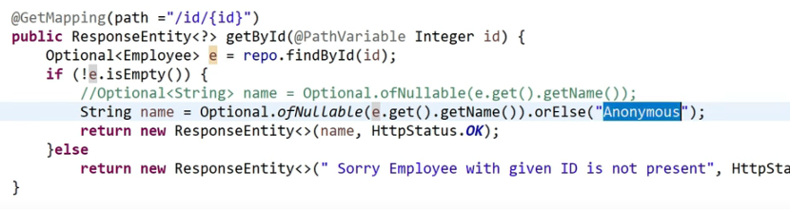

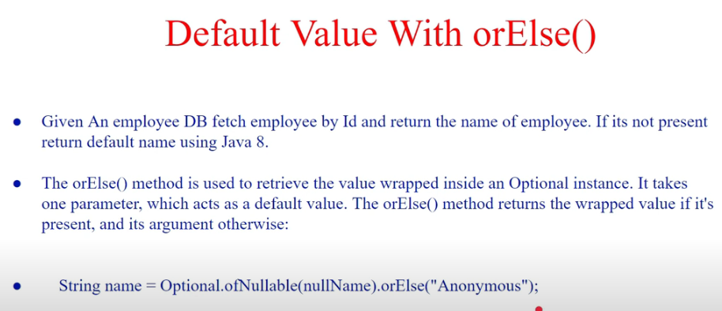

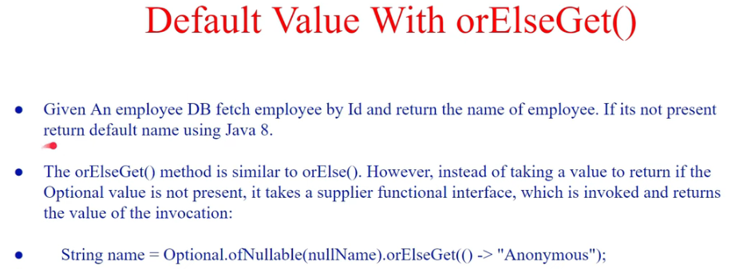

### Why orElseGet(()->call()) Why not orElse(call())?

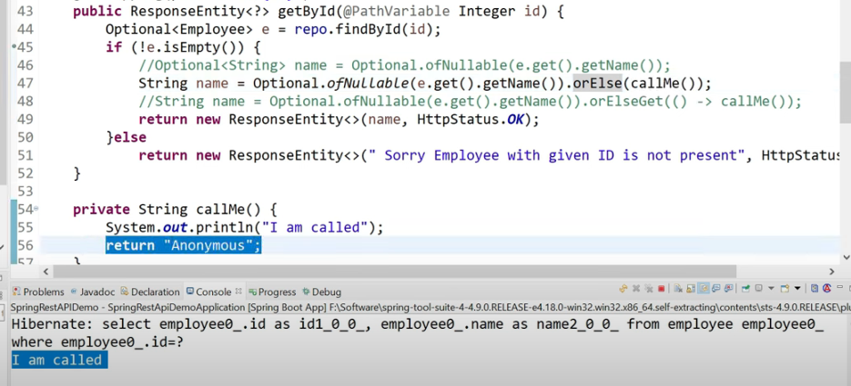

Even for not null values callMe is getting called with orElse(), Not the case with orElseGet().

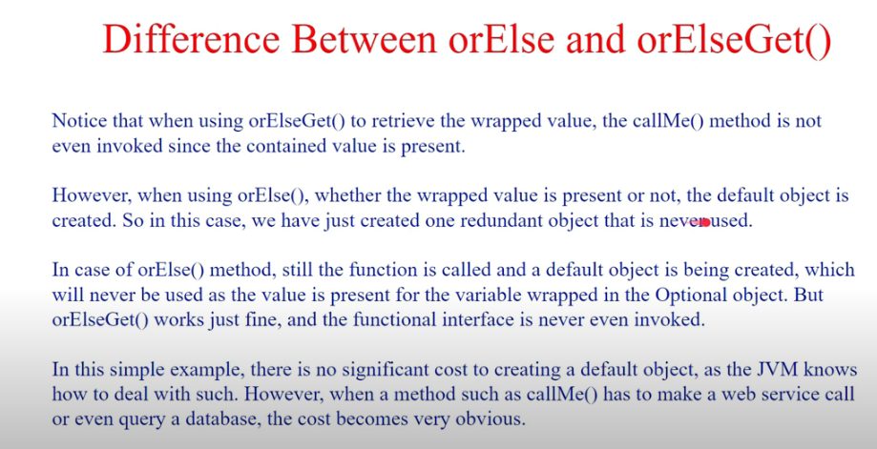

### **orElseThrow()**

**Start with why?**

orElseThrow(() -> new Exception("Optional is empty")) is used to throw an exception with the message "Optional is empty" when the Optional is empty. The orElseGet() equivalent would be orElseGet(() -> { throw new Exception("Optional is empty"); }), but this is generally less readable and more verbose.

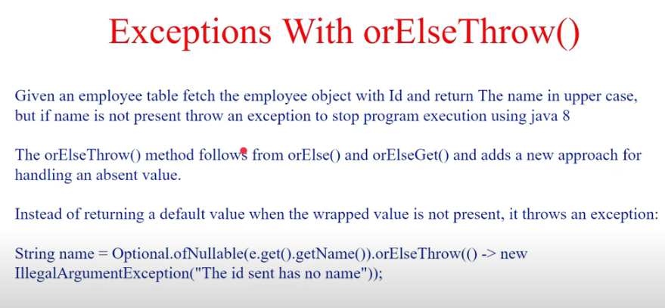

## Iterate() in Stream

**Parameters:** This method accepts three parameters:

* **seed**: which is the initial element,
* **hasNext**: which is a predicate to apply to elements to determine when the stream must terminate and
* **next**: which is a function to be applied to the previous element to produce a new element.

#### create a stream using iterate

<https://mkyong.com/java8/java-8-stream-iterate-examples/>

Java 8 iterates has no predicate to limit the stream so they giving an infinite stream & we need to stop using limit, java 9 introduced predicate.

Stream<Integer> stream

= Stream.iterate(1,

i -> i <= 20, i -> i * 2);

// print Values

stream.forEach(System.out::println);

#### Modify List

List<Integer> numbers = Arrays.asList(1, 2, 3, 4, 5);

Stream.iterate(0,i->i<numbers.size(),i->i+1).forEach(i->numbers.set(i,numbers.get(i)*numbers.get(i)));

System.out.println(numbers);

#### with infinite stream & limit()

Stream.iterate(0, n -> n + 1).limit(10).forEach(System.out::println);

## .peek() in Stream

allows us to perform some action (printing in this case) without affecting the elements of the stream. It's useful for debugging or logging purposes.

<https://www.baeldung.com/java-streams-peek-api>

## ShortCircuit Operation

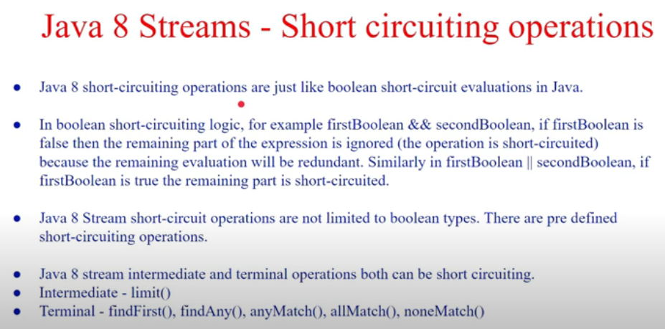

Types of Operations in ShortCircuit Operation.

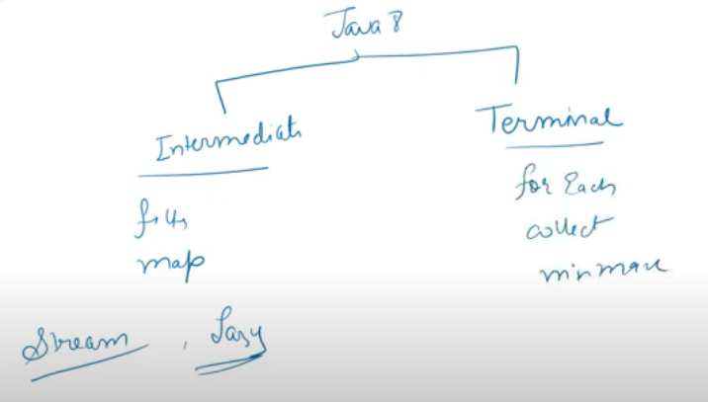

### Intermediate

#### limit

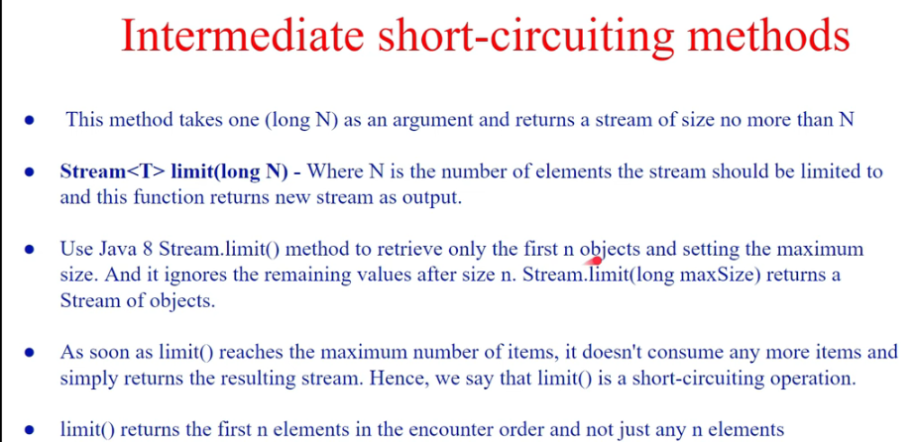

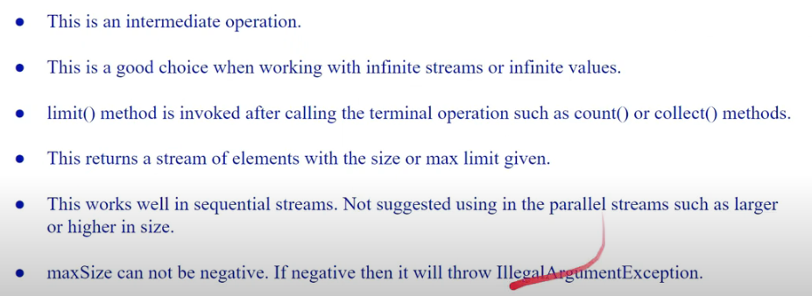

#### findFirst

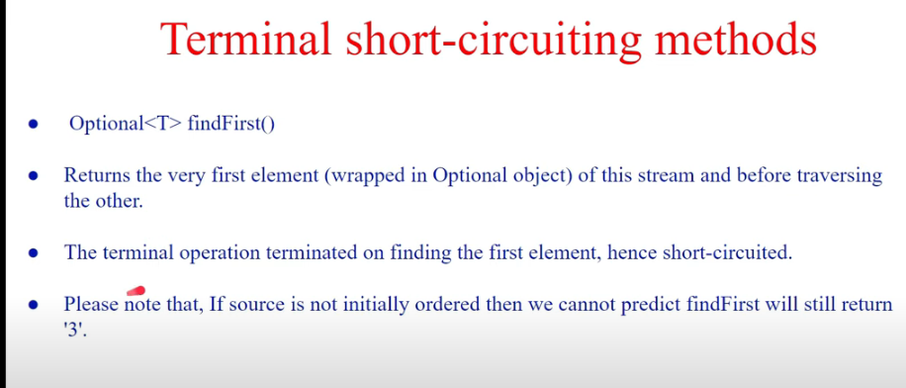

#### findAny

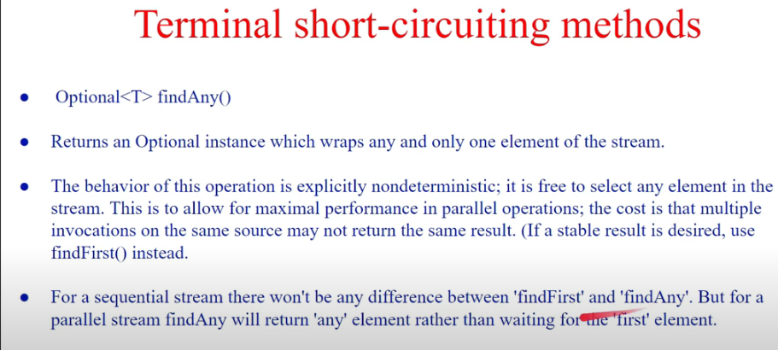

#### findFirst vs findAny (why they are giving same result?)



The difference is only seen when we use parallel streams.

#### anyMatch

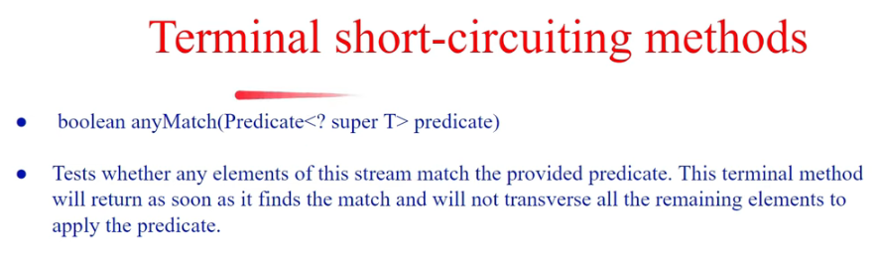

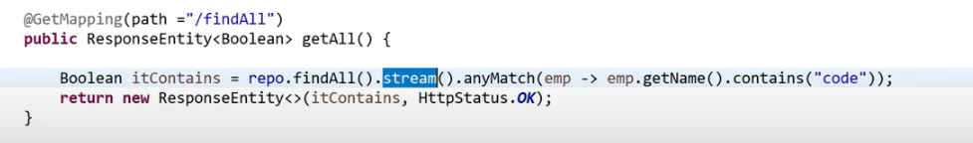

#### noneMatch

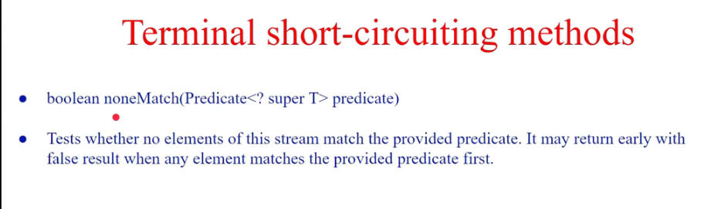

## Flatmap

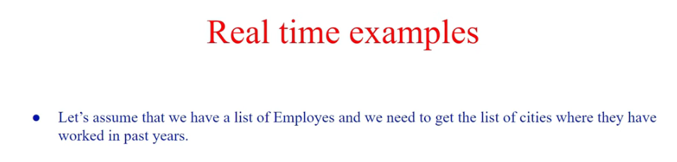

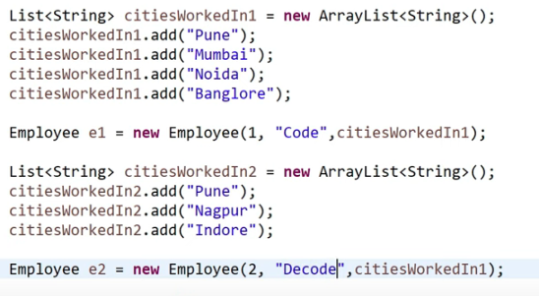

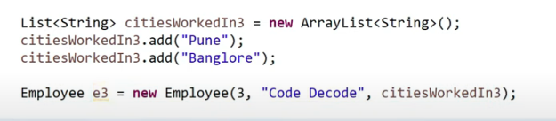

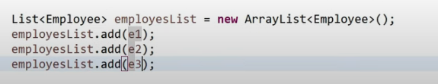

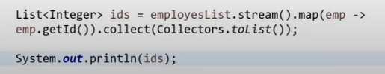

Do my employees get Modified? Ans: No

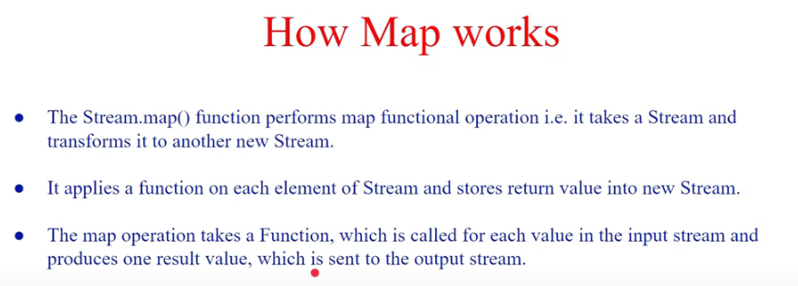

When we Try to Solve initial Question with Map..





Even though we used Set to collect the list of cities we get the duplicates. The Requirement is Not get duplicates like pune is repeating.

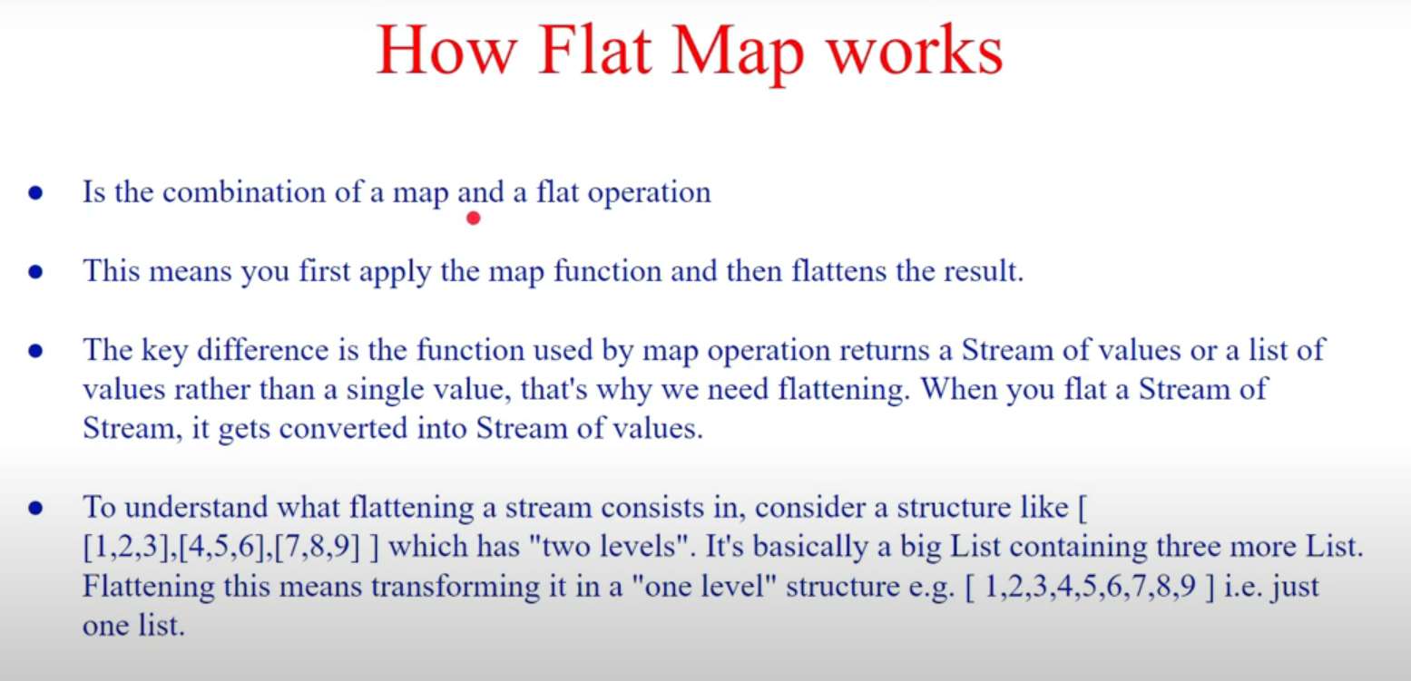

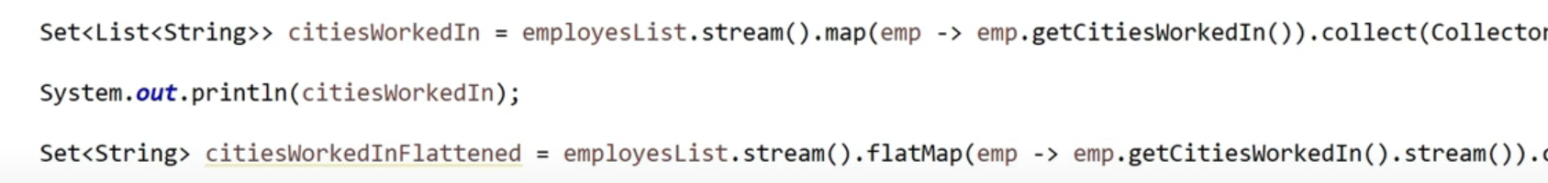



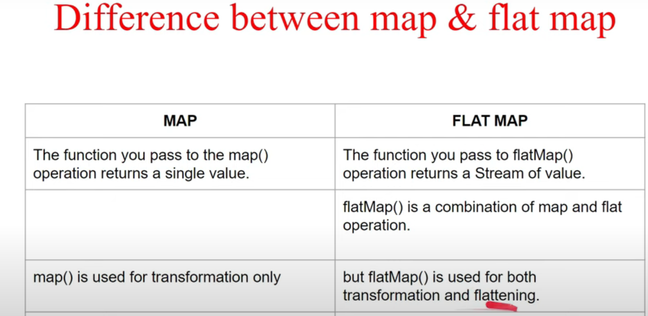

Enough skip this below pic. just repeated things

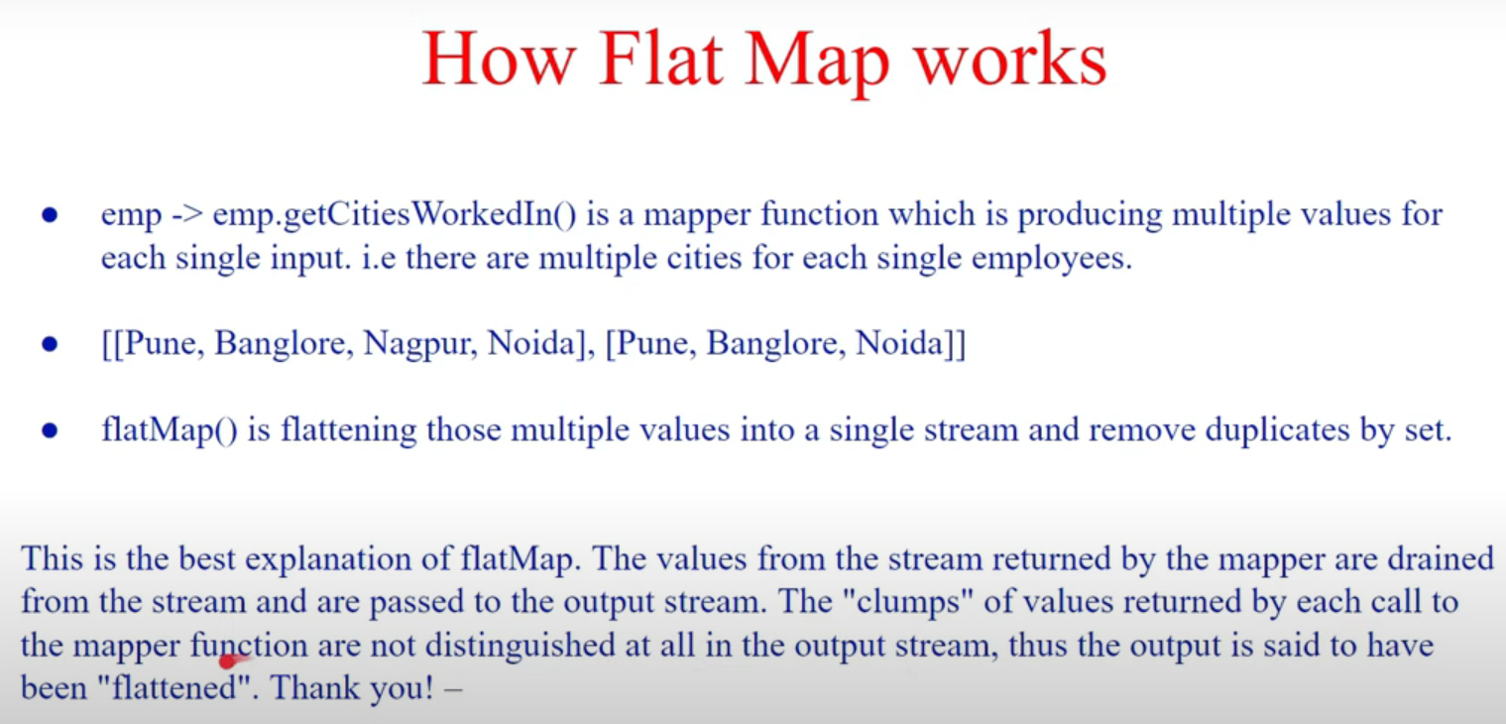

## IntStream

### .generate() // generates From nothing ()->something

// Generate a constant stream of the same integer

IntStream.generate(() -> 10).limit(10).forEach(System.out::println);

// Generate a stream of random integers

IntStream.generate(() -> new Random().nextInt()).limit(10).forEach(System.out::println);

// Generate a stream of integers from 1 to 10

IntStream.generate(() -> {

int i = 1;

return ++i;

}).limit(10).forEach(System.out::println);

## 

## collect

short Notes

### **Collectors**

Certainly! Let's dive deeper into the `collect` method in Java streams, exploring its various forms and concepts.

### Basics of `collect` method:

The `collect` method in Java streams is used to accumulate elements into a mutable result container, such as a `List`, `Set`, or `Map`. It provides a way to transform a stream of elements into a different form, like a collection, array, or a single result.

### Syntax:

The general syntax of the `collect` method is:

```java

<R> R collect(Supplier<R> supplier, BiConsumer<R, ? super T> accumulator, BiConsumer<R, R> combiner)

```

- `supplier` is a function that creates a new mutable result container.

- `accumulator` is a function that accumulates elements into the result container.

- `combiner` is used to combine the results of multiple result containers in parallel processing.

### Let's explore different ways to use `collect`:

#### 1. Accumulate elements into a List:

```java

List<String> list = Stream.of("one", "two", "three")

.collect(ArrayList::new, ArrayList::add, ArrayList::addAll);

System.out.println(list); // Output: [one, two, three]

```

- `ArrayList::new` creates a new `ArrayList` as the initial result container.

- `ArrayList::add` is the accumulator, adding elements to the `ArrayList`.

- `ArrayList::addAll` is the combiner, used in parallel streams to combine results.

#### 2. Accumulate elements into a HashSet:

```java

Set<String> set = Stream.of("apple", "banana", "cherry")

.collect(HashSet::new, HashSet::add, HashSet::addAll);

System.out.println(set); // Output: [banana, apple, cherry]

```

- `HashSet::new` creates a new `HashSet`.

- `HashSet::add` adds elements to the `HashSet`.

- `HashSet::addAll` is the combiner.

#### 3. Convert to an array:

```java

String[] array = Stream.of("Java", "Python", "C++")

.toArray(String[]::new);

System.out.println(Arrays.toString(array)); // Output: [Java, Python, C++]

```

- `String[]::new` creates a new array to hold the elements.

#### 4. Transform to a Map:

```java

Map<Integer, String> map = Stream.of("apple", "banana", "cherry")

.collect(Collectors.toMap(String::length, Function.identity()));

System.out.println(map); // Output: {5=apple, 6=banana, 7=cherry}

```

- `String::length` is the key mapper.

- `Function.identity()` is the value mapper, returning the element itself.

#### 5. Custom collector - Accumulate to StringBuilder:

```java

StringBuilder result = Stream.of("a", "b", "c")

.collect(StringBuilder::new, StringBuilder::append, StringBuilder::append);

System.out.println(result); // Output: abc

```

- `StringBuilder::new` creates a new `StringBuilder`.

- `StringBuilder::append` appends each element to the `StringBuilder`.

- No combiner is needed as it's a sequential operation.

#### 6. GroupingBy with downstream collector:

```java

Map<Integer, List<String>> groupedByLength = Stream.of("apple", "banana", "cherry")

.collect(Collectors.groupingBy(String::length));

System.out.println(groupedByLength); // Output: {5=[apple], 6=[banana, cherry]}

```

- `Collectors.groupingBy` groups elements based on their lengths.

- It uses a downstream collector (by default `toList()`) to collect values into a list.

### Conclusion:

The `collect` method in Java streams is a versatile tool for transforming and accumulating elements from a stream into various data structures. By using different suppliers, accumulators, and combiners, we can achieve a wide range of operations, from simple collections to complex groupings and custom aggregations.

#### .groupingBy (returns Map)

|  |  |
| --- | --- |

Map<Integer,List<Employee>>abc=lis.stream().collect(Collectors.groupingBy(e->e.getAge())

@GetMapping("/Collectors")

*public* ResponseEntity<*Map*<Integer,*Set*<Employee>>> display()

{

Employee emp6 = *new* Employee(101, "Alice", 30);

Employee emp5 = *new* Employee(102, "Bob", 30);

Employee emp3 = *new* Employee(103, "Alice", 30);

Employee emp4 = *new* Employee(104, "Bill", 29);

Employee emp2 = *new* Employee(105, "Aron", 31);

Employee emp1 = *new* Employee(106, "Brook", 28);

*List*<Employee>lis=*List*.*of*(emp1,emp2,emp3,emp4,emp5,emp6);

*Map*<Integer, *Set*<Employee>>abc = lis.stream().collect(Collectors.*groupingBy*(e -> e.getAge(),TreeMap::*new*, Collectors.*toSet*()));

*return new* ResponseEntity<>(abc, HttpStatus.OK);

}

By default groupingBy(This has to mentioned , HashMap::new, Collectors.toList());

we changed to treeMap & set here.

1. groupingBy(Function, Collector), internally calls 3.
2. groupingBy(Function), internally calls 1.
3. groupingByConcurrent(Function, Supplier, Collector) calls Nobody.

*groupingBy*(*Function*.*identity*(),TreeMap::*new*,Collectors.*counting*())

Function.identity() is nothing but s->s. FUNCTION

Collectors.counting() counts the no of values. COLLECTOR

#### .toList()

#### .toMap

Stream<Map.Entry<String, Integer>> keyValueStream = Stream.of(

Map.entry("Apple", 10),

Map.entry("Banana", 20),

Map.entry("Cherry", 15)

);

##### keyValueStream

// Collecting the key-value pairs into a TreeMap

TreeMap<String, Integer> treeMap = keyValueStream

.collect(Collectors.toMap(

Map.Entry::getKey,

Map.Entry::getValue,

(oldValue, newValue) -> oldValue, // Merge function (if keys are duplicated)

TreeMap::new // Supplier for TreeMap

));

**Explanation:**

1. Tell the map where to get the Key
2. Tell the map where to get the Value
3. Tell the map that if two values are there for same key(two same keys with different values). then keep only the OldValue
4. Name the type of Map you want.

##### reverse TreeMap

collect(Collectors.toMap(

Map.Entry::getKey,

Map.Entry::getValue,

(oldValue, newValue) -> oldValue,

() -> new TreeMap<>(java.util.Collections.reverseOrder())

));

#### .toCollection

Collectors.toCollection(() -> new TreeSet<>(Comparator.reverseOrder()))

#### .collectingAndThen

**e.g 1:**

import java.util.Arrays;

import java.util.stream.Collectors;

public class Main {

public static void main(String[] args) {

int[] array = {1, 2, 3, 4, 5};

// Reversing the array using streams

int[] reversedArray = Arrays.stream(array)

.boxed() // Convert int to Integer

.collect(Collectors.collectingAndThen(

Collectors.toList(),

list -> {

java.util.Collections.reverse(list);

return list.stream().mapToInt(Integer::intValue).toArray();

}

));

// Print the reversed array

System.out.println("Original Array: " + Arrays.toString(array));

System.out.println("Reversed Array: " + Arrays.toString(reversedArray));

}

}

Output:

Original Array: [1, 2, 3, 4, 5]

Reversed Array: [5, 4, 3, 2, 1]

**e.g 2:**

HashMap<Character, Integer> hm = word.chars()

.mapToObj(c -> (char) c)

.collect(Collectors.groupingBy(

Function.identity(),

HashMap::new,

Collectors.collectingAndThen(Collectors.counting(), Long::intValue)

));

#### .partitioningBy()

List<Integer> numbers = Arrays.asList(1, 2, 3, 4, 5);

Map<Boolean, List<Integer>> evenOddMap = numbers.stream()

.collect(Collectors.partitioningBy(n -> n % 2 == 0));

If you want to use on arrays you should use .boxed()

#### .joining()

`Collectors.joining()` is a terminal operation provided by the `Collectors` utility class in Java, which is used to concatenate the elements of a stream into a single `String`. It's particularly useful when you want to join the elements of a stream with a delimiter, and optionally with a prefix and suffix.

Here's an explanation with simple to medium examples:

### Basic Example:

Suppose you have a list of strings and you want to join them into a single comma-separated string:

```java

import java.util.Arrays;

import java.util.List;

import java.util.stream.Collectors;

public class JoiningExample {

public static void main(String[] args) {

List<String> names = Arrays.asList("John", "Jane", "Doe", "Alice");

// Join the names with a comma and space

String result = names.stream()

.collect(Collectors.joining(", "));

System.out.println(result);

}

}

```

Output:

```

John, Jane, Doe, Alice

```

### Example with Prefix and Suffix:

You can also specify a prefix and a suffix for the resulting joined string:

```java

import java.util.Arrays;

import java.util.List;

import java.util.stream.Collectors;

public class JoiningExample {

public static void main(String[] args) {

List<String> fruits = Arrays.asList("Apple", "Banana", "Orange");

// Join the fruits with a comma, space, and surrounded by [ and ]

String result = fruits.stream()

.collect(Collectors.joining(", ", "[", "]"));

System.out.println(result);

}

}

```

Output:

```

[Apple, Banana, Orange]

```

### Example with Empty List:

When the stream is empty, `Collectors.joining()` returns an empty string by default:

```java

import java.util.Collections;

import java.util.stream.Collectors;

public class JoiningExample {

public static void main(String[] args) {

// Empty list

String result = Collections.emptyList().stream()

.collect(Collectors.joining(", "));

System.out.println("Result: \"" + result + "\"");

}

}

```

Output:

```

Result: ""

```

### Example with StringBuilder:

Under the hood, `Collectors.joining()` uses a `StringBuilder` to perform the concatenation efficiently. You can also use a `StringBuilder` explicitly to achieve similar results:

```java

import java.util.Arrays;

import java.util.List;

public class JoiningExample {

public static void main(String[] args) {

List<String> words = Arrays.asList("Hello", "world", "from", "Java");

StringBuilder resultBuilder = new StringBuilder();

for (String word : words) {

if (resultBuilder.length() > 0) {

resultBuilder.append(", ");

}

resultBuilder.append(word);

}

String result = resultBuilder.toString();

System.out.println(result);

}

}

```

Output:

```

Hello, world, from, Java

```

**### Summary:**

- `Collectors.joining()` is used to concatenate the elements of a stream into a single `String`.

- It takes an optional delimiter, prefix, and suffix.

- The delimiter is inserted between each element.

- The prefix is added at the beginning of the result.

- The suffix is added at the end of the result.

- If the stream is empty, it returns an empty string.

- It's efficient and can handle large streams of data.

## Array Problems with streams

### Print Fibonacci Series using Streams

Trick → Asking fibonacci? you print palindrome 101.

int n=10;

Stream.iterate(new int[]{0,1},x->new int[]{x[1],x[0]+x[1]}).mapToInt(y->y[0]).limit(n).forEach(System.out::println);

### Second smallest element

Given an array of integers, write a Java 8 program to find the second smallest element

**For second smallest:  
→** List.of(1,2,35,45).stream().sorted().skip(1).limit(1).forEach(System.out::print);

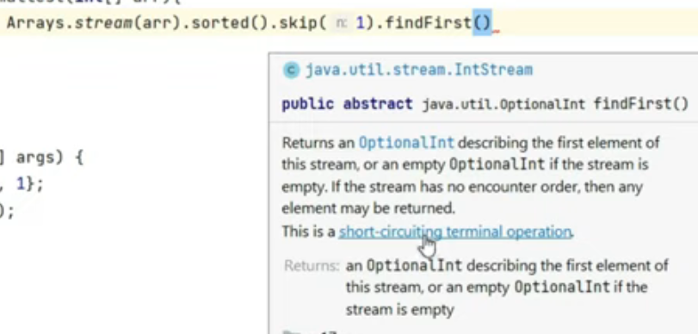

findFirst is a short-circuiting terminal operation. removes other elements from the stream & gets 1st one. **returns optional int.**

**Arrays.stream(arr).sorted().skip(1).findFirst().orElseThrow(()->new Illegal ArgExce(“not present”));**

**Arrays.stream(arr).sorted().skip(1).findFirst().get()** (Not recommended but works because no check by isPresent()). isPresent implementation →boolean exists=Arrays.stream(arr).sorted().skip(1).limit(1).findFirst().isPresent();

System.out.println(exists);

Hi ** Hidden here

we also have findAny() which also returns optional.

int[] arr=new int[]{2};

int ans=Arrays.stream(arr).sorted().skip(1).limit(1).findAny().orElse(-1);

System.out.println(ans);

**For second Largest:**

System.out.println(List.of(1,2,35,45).stream().sorted((a,b)->b-a).skip(1).limit(1).collect(Collectors.toList()));

**IntelliJ Magic conversion of above code:** System.out.println(Stream.of(1,2,35,45).sorted((a,b)->b-a).skip(1).limit(1).collect(Collectors.toList()));

System.out.println(Stream.of(1,2,35,45).sorted(Comparator.reverseOrder()).skip(1).limit(1).collect(Collectors.toList()));

System.out.println(List.of(1,2,35,45).stream().sorted(Collections.reverseOrder()).skip(1).limit(1).collect(Collectors.toList()));

List.of(1,2,35,45).stream().sorted(Collections.reverseOrder()).skip(1).limit(1).forEach(System.out::print);

**The Above all answer’s are wrong? I expect you got what missed before.**

Now Interviewer will ask what’s the answer for {3,2,8,5,1,1}?

Soln : (Highlight & see) apply distinct() before sorted()

### Common Elements between Arrays

int arr1[]={1,2,3,4};

int arr2[]={3,4,5,6,7};

*int*[] arr1 ={1,2,3,4};

*int*[] arr2 ={3,4,5,6,7};

Arrays.*stream*(arr1).filter(num->(Arrays.*stream*(arr2).anyMatch(n->n==num))).forEach(System.out::print);

*List*<Integer>lis=Arrays.*stream*(arr1).filter(num->Arrays.*stream*(arr2).anyMatch(n->n==num)).boxed().collect(Collectors.*toList*());

System.out.println(lis);

### Reverse an Array Inplace

#### Normal reverse an Array:

int[] reversed=IntStream.range(0,arr1.length).map(n->arr1[arr1.length-1-n]).toArray();

Ok. this is just using some tricks.. Now see using java 9 iterate..

int[] reverse=IntStream.iterate(arr.length - 1, i -> i >= 0, i -> i - 1)

.map(n->arr[n]).toArray();

**range()** method generates a stream of numbers starting from start value but stops before reaching the end value, i.e start value is inclusive and end value is exclusive. Example: IntStream.range(1,5) generates a stream of ‘1,2,3,4’ of type int.

**rangeClosed()** method generates a stream of numbers starting from start value and stops after generating the end value, i.e start value is inclusive and end value is also inclusive. Example: LongStream.rangeClosed(1,5) generates a stream of ‘1,2,3,4,5’ of type long.

**ChatGPT**

int[] array = {1, 2, 3, 4, 5};

// Reversing the array using streams

int[] reversedArray = Arrays.stream(array)

.boxed() // Convert int to Integer

.collect(Collectors.collectingAndThen(

Collectors.toList(),

list -> {

java.util.Collections.reverse(list);

return list.stream().mapToInt(Integer::intValue).toArray();

}

));

#### Inplace reverse Array:

IntStream.range(0,arr1.length/2).forEach(

n->{

int temp=arr1[n];

arr1[n]=arr1[arr1.length-n-1];

arr1[arr1.length-n-1]=temp;

}

);

Arrays.stream(arr1).forEach(n->System.out.println(n+" "));

**for better printing:**  System.out.println(Arrays.toString(arr1));

### Longest String in Array of Strings

#### To find Length of longest String:

String[]str={"ad","asd","hello"};

int ans= Arrays.stream(str).mapToInt(String::length).max().orElse(0);

System.out.println(ans);

#### To find the longest String:

##### BruteForce

String ss=Arrays.stream(str).filter(s->Arrays.stream(str).mapToInt(String::length).max().orElse(0)==s.length()).findFirst().get();

System.out.println(ss);

##### Using max

Optional<String> longestString = Arrays.stream(str)

.max((s1, s2) -> s1.length() - s2.length());

// Check if the longest string is present and print it

longestString.ifPresent(s -> System.out.println("Longest String: " + s));

##### Using reduce

List<String> words = Arrays.asList("GFG", "Geeks", "for",

"GeeksQuiz", "GeeksforGeeks");

// The lambda expression passed to

// reduce() method takes two Strings

// and returns the longer String.

// The result of the reduce() method is

// an Optional because the list on which

// reduce() is called may be empty.

Optional<String> longestString = words.stream()

.reduce((word1, word2)

-> word1.length() > word2.length()

? word1 : word2);

// Displaying the longest String

longestString.ifPresent(System.out::println);

#### Using Map.Entry

String longestString=Arrays.stream(str).map(n->Map.entry(n.length(),n)).sorted((a,b)->b.getKey()-a.getKey()).map(Map.Entry::getValue).findFirst().orElse("No elements Present");

System.out.print(longestString);

#### Both(length & value) with groupingBy & collectors.Map

String[]str={"ad","asd","hello"};

Map.Entry<Integer,List<String>>lis=Arrays.stream(str).collect(Collectors.groupingBy(String::length,()->new TreeMap<>(Comparator.reverseOrder()),Collectors.toList())).firstEntry();

System.out.println(lis.getKey()+" "+lis.getValue().get(0));

#### Using TreeMap

String longestString= Arrays.stream(str).collect(Collectors.toMap(

String::length,

s->s,

(a,b)->a,

()->new TreeMap<>(Collections.reverseOrder())

)).firstEntry().getValue();

### Remove Duplicates in String while Preserving the order

#### Using Collectors.toCollection

String s="hello";

LinkedHashSet<Character>lhs=s.chars().mapToObj(n->(char)n).collect(Collectors.toCollection(LinkedHashSet::new));

System.out.println(lhs);

#### Using reduce

##### using String

String ss=s.chars().distinct().mapToObj(Character::toString).reduce((a, b)->a+b).orElse("");

##### using StringBuilder

**Brute:**

StringBuilder ss=s.chars().distinct().mapToObj(c->new StringBuilder((char)c)).reduce(StringBuilder::append).orElse(new StringBuilder(""));

**Better:**

StringBuilder ss = new StringBuilder();

s.chars().distinct().forEach(c -> ss.append((char) c));

**Best:**StringBuilder ss = s.chars()

.distinct()

.collect(StringBuilder::new, StringBuilder::appendCodePoint, StringBuilder::append);

**StringBuilder appendCodePoint() method in Java**

int value in parameter is converted to a char array and the character in that array were then appended to this character sequence. ok!! basicall it converts our intstream to char and appends it.

**collect (1,2,3) →**

1 is supplier, 2 is accumulator, 3 is combiner (used in parallel streams).

ll

### Remove Dups in List of String

**3 Approach**

1. Using add() method of Set to verify the element is already present or not.

2. Using groupingBy() method.

3. Using frequency() method of Collections class.

**Using add()**

String[] s=[“hello”,”how”,”hello”,”you”];

HashSet<String>hs=new HashSet<>();

List<String>ls=Arrays.stream(s).filter(n->!(hs.add(n))).distinct().collect(Collectors.toList());

**Using groupingBy()**

String[]s="hello hi hello bye".split(" ");

Map<String,Long>hm=Arrays.stream(s).collect(Collectors.groupingBy(S->S,Collectors.counting()));

// We cannot convert map to Stream again Since, map is not a collection.

hm.forEach((k,v)->{

if(v>1)

System.out.println(k);

});

***//we cannot convert the map to collection. but we can do with entrySet.***

**String[] ans=hm.entrySet().stream().filter(n->n.getValue()>1).map(*Map*.*Entry*::getKey).toArray(String[]::*new*);**

**System.out.println(Arrays.*toString*(ans));**

**Using Frequencey method.**

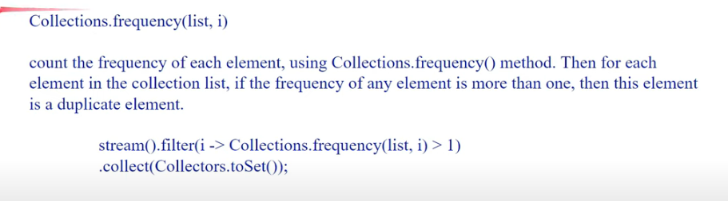

**String[] s = "hello hi hello bye".split(" ");**

**String[] duplicates = Arrays.stream(s).filter(n -> Collections.frequency(Arrays.asList(s), n) > 1).distinct().toArray(String[]::new);**

**System.out.println(Arrays.toString(duplicates));**

### Array of Product of other elements than Current element

**BruteForce:**

int[]arr=new int[]{10,100,1000,2};

**// if distinct elements**

int[] prodArr=Arrays.stream(arr).map(n->Arrays.stream(arr).filter(x->x!=n).reduce((a,b)->a*b).orElse(-1)).toArray();

System.out.println(Arrays.toString(prodArr));

**//if not distinct elements**

int[] prodArr2=IntStream.range(0,arr.length).map(i->IntStream.range(0,arr.length).filter(j->j!=i).map(a->arr[a]).reduce((a,b)->a*b).orElse(-1)).toArray();

System.out.println(Arrays.toString(prodArr2));

**Optimal:**

int totalProduct=Arrays.stream(arr).reduce((a,b)->a*b).orElse(-1);

int[] prodArr3=Arrays.stream(arr).map(n->totalProduct/n).toArray();

System.out.println(Arrays.toString(prodArr3));

### No of Occurences of words in given String using Java8

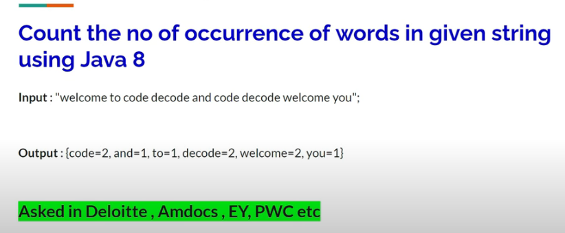

String s=”welcome to code decode and code decode”;

**ans:** Arrays.stream(s.split(“ “)).collect(Collectors.groupingBy(Function.identity**()**,Collectors.counting()))

**ans2:**Arrays.stream(s.split(“ “)).distinct().collect(Collectors.toMap(Function.identity

n->Collections.Frequency(Arrays.asList(s.split(“ ”)),n)

Above are Written for Practice. See what mistakes you did above by referring below.

String s="welcome to code decode and code decode welcome you";

*Map*<String,Long>ans=Arrays.*stream*(s.split(" ")).collect(Collectors.*groupingBy*(*Function*.*identity*(),Collectors.*counting*()));

System.out.println(ans);

*Map*<String,Integer>ans2=Arrays.*stream*(s.split(" ")).distinct().collect(Collectors.*toMap*(n->n,

n-> Collections.*frequency*(Arrays.*asList*(s.split(" ")),n)));

System.out.println(ans2);

}

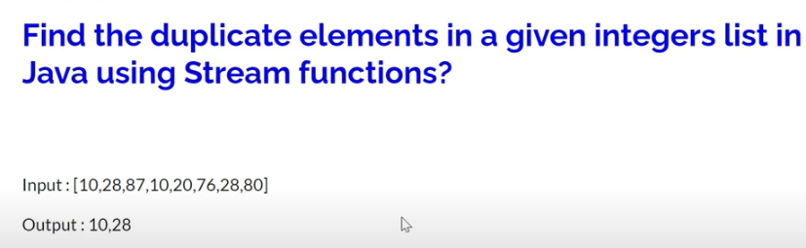

### Implement Isprime using Java 8

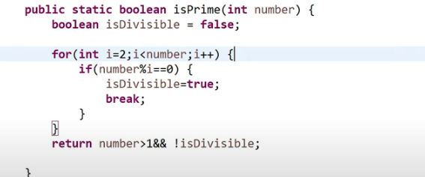

takes Integer & return boolean.

BiFunction<Integer,Integer,Integer> multiply=(a, b)->a*b;

Predicate<Integer> isPrimeusingJava9= n-> Stream.iterate(2, i->i<n, i->i+1).noneMatch(i->n%i==0);

Predicate<Integer>isPrimeusingJava8= n->IntStream.range(2,n).noneMatch(i->n%i==0);

check what you did wrong above

*Predicate*<Integer> isPrimeusingJava9= n-> (n!=1) && *Stream*.*iterate*(2, i->i<n, i->i+1).noneMatch(i->n%i==0);

*Predicate*<Integer>isPrimeusingJava8= n->(n!=1) && *IntStream*.*range*(2,n).noneMatch(i->n%i==0);

System.out.println(isPrimeusingJava9.test(13));

System.out.println(isPrimeusingJava8.test(1));

**n>1 is Even Better**

System.out.println(isPrimeusingJava9.test(14));

System.out.println(isPrimeusingJava8.test(17));

### Square Root of first 10 prime numbers to List

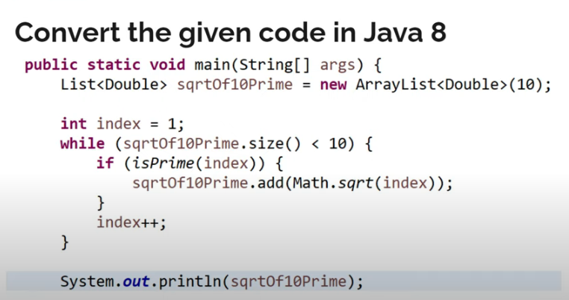

Predicate<Integer>isPrime=n-> {

System.out.println(n);

return n!=1 && IntStream.rangeClosed(2,(int)Math.sqrt(n)).noneMatch(i->n%i==0);};

List<Double>first10PrimesSqrt=Stream.iterate(1,i->i=i+1).filter(isPrime).limit(10).map(Math::sqrt).collect(Collectors.toList());

System.out.println(first10PrimesSqrt);

### Exercise Question:

String statement = "Hello World My name is Jane and I hate Mango Fruit";

Output=> {5 = [“Hello”, “World”, “Mango”, “Fruit”], 4 = [“name”, “Jane”, “hate”],

3 = [“and”], 2 = [“My”, “is”], 1 = [“I”]}

This one I did in yt comments

class Employee

{

String name;

String cityName;

Employee(String name, String cityName)

{

this.name=name;

this.cityName=cityName;

}

@Override

public String toString() {

return this.name;

}

}

Employee e1=new Employee("Rahul","Raipur");

Employee e4=new Employee("ramesh","Raipur");

Employee e2=new Employee("Luck","LosAngels");

Employee e3=new Employee("Tom","Turkey");

List<Employee>lis=new ArrayList<>();

lis.add(e1);lis.add(e2);lis.add(e3);lis.add(e4);

Map<String,List<Employee>>mp=lis.stream().collect(Collectors.groupingBy(e->e.cityName));

mp.forEach((k,v)->{

System.out.print(k+": ");

System.out.println(v);

});

#### Will Arrays.stream works for

Integer[] arr2={1,2,3,4,5};

Ans: Yes.

*public static* <T> *Stream*<T> stream(T[] array) {

*return stream*(array, 0, array.length);

}

//int[] arr=new int[]{1,2,3,4,5};

Integer[] arr={1,2,3,4,5};

int product=Arrays.stream(arr).reduce((a,b)->a*b).orElse(-1);

System.out.print(product);

Integer[] arr2={1,2,3,4,5};

int pp= Arrays.asList(arr2).stream().reduce((a,b)->a*b).orElse(-1);

System.out.print(pp);

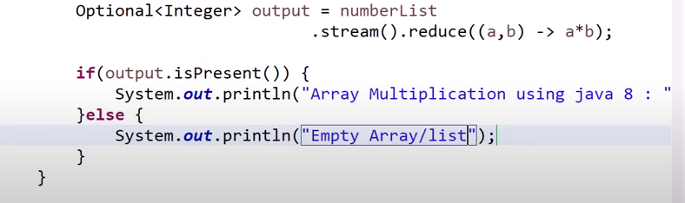

Use this for Ip.

**My mix:**

Integer[] arr2={};

Arrays.stream(arr2).reduce((a, b)->a*b).ifPresentOrElse(System.out::print,()->System.out.println("empty array"));